Shri Shambhubhai V. Patel College Of

Computer Science and Business Management

Sumul Dairy Road, Surat

Veer Narmad South Gujarat University, Surat

SEMINAR REPORT

ON

**SURFACE COMPUTER**

AS Partial Requirement for the Degree

Of

Bachelor of Computer Application

(B.C.A) during 6th semester

YEAR: 2016-2017

Submitted By: Guided By:

Krishna koladiya Maitri

MICROSOFT

SURFACE COMPUTER

TECHNOLOGY

INDEX

|  |  |  |
| --- | --- | --- |
| SR NO. | PARTICULAR | PAGE NO. |
| 1. | History |  |
| 2. | Introduction |  |
| 3. | Topic Detail |  |
| 4. | Topic Application |  |
| 5. | Advantages & Disadvantages |  |
| 6. | Future enhancement |  |
| 7. | Conclusion |  |
| 8. | References |  |
| 9. |  |  |
| 10. |  |  |
| 11. |  |  |

1. **History:**

* 1982: University of Toronto and Bell Laboratory developed first multi-touch display.
* 2001: The product idea for Surface was initially conceptualized by Steven Bathiche .
* 2003:1 st prototype (t1 ) was produced to bill gets for appruval
* 2004: Microsoft built more than 85 early prototypes for Surface.
* 2005: The final hardware design was completed.
* 2007: Interactive table top device was designed than seamlessly bring both the physical and virtual words into one.

**2)Introduction:**

* Multi-touch product from Microsoft.
* Software and Hardware combination.
* A computer in the form of a table, using the hard acrylic tabletop as a high-resolution screen.
* New way to interact with information(data).
* Interaction with photos, contents, maps, menus in different way.
* Provide new opportunities for companies to engage with people.
* Makes everyday tasks entertaining, enjoyable and efficient.

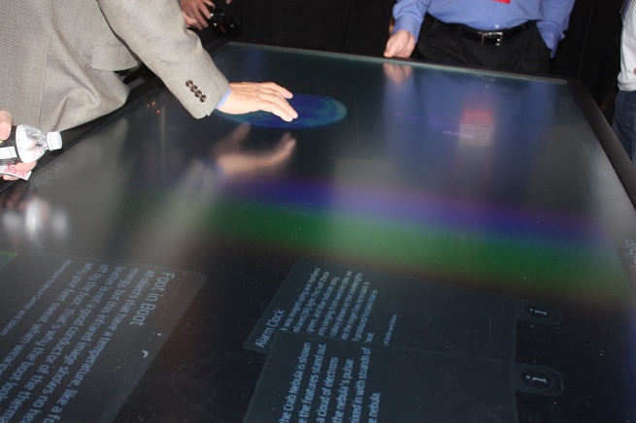

1. **Detail:**

* **How does it work?**
  + - Gives a touch interface but it doesn’t use touch screen.
    - The Surface is not a touch-sensitive screen device… The screen itself is not electronic
    - The Surface uses multiple infrared cameras beneath the screen/table top to sense objects, physical touch, etc.
    - The Surface “recognizes objects based on shape or by using domino-style identification (domino tags) on thebottom of the objects.”
    - This information is processed and displayed using “rear projection”
* **Inside The Surface Computer**

1. Display

2. Infrared cameras

3. CPU

4. Projector

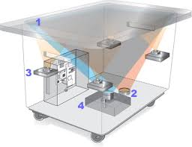

1. **Display**

* Displays for surface computing can range from [LCD](https://en.wikipedia.org/wiki/LCD) and [projection screens](https://en.wikipedia.org/wiki/Projection_screens) to physical object surfaces.
* Alternatively, an augmented reality headset may be used to display images on real-world objects.
* Displays can be divided into single-viewpoint and multi-viewpoint displays.
* Single-viewpoints include any flat screen or surface where viewing is typically done from one angle.
* A multi-viewpoint display would include any three-dimensional object surface like a sphere or cylinder that allows viewing from any angle.

**2. Infrared cameras**

* Infrared or thermo graphic cameras are used to facilitate gestural detection.
* Unlike digital cameras, infrared cameras operate independent of light, instead relying on the heat signature of an object. This is beneficial because it allows for gesture detection in all lighting conditions. However, cameras are subject to occlusion by other objects that may result in a loss of gesture tracking. Infrared cameras are most common in three-dimensional implementations.

**3. CPU**

* Core 2 Duo processors 2GB of RAM 256 MB newish video cards.
* Wireless communication using Wi-Fi and Bluetooth antennas.
* Operating System: Modified version of Microsoft vista.

**4. Projectors**

* If a projection screen or a physical object surface is being used, a projector is needed to superimpose the image on the display. A wide range of projectors are used including DLP, LCD, and LED. Front and rear projection techniques are also utilized. The advantage of a projector is that it can project onto any arbitrary surface. However, a user will end up casting shadows onto the display itself, making it harder to identify high detail
* **How does Multi Touch Screen Work??**

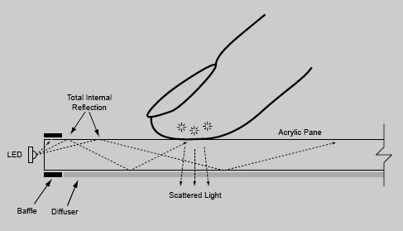

* Perceptive Pixel’s touch screens work via frustrated total internal reflection Technology.
* The acrylic surface has infrared LEDs on the edges. When one or more fingers touch the surface, the light diffuses at the contact points, changing the internal-reflection pathways.
* A camera below the surface captures the diffusion and sends the information to image- processing software, which translates it into a command.
* **How is the Surface used?**
  + - Wireless! Transfer pictures from camera to Surface and cellphone. “ Drag and drop virtual content to physical objects.”
    - Digital interactive painting
    - At a phone store? Place cell phone on the Surface and getinformation, compare different phones, select service plan,accessories, and pay at table!
    - At a restaurant? View menu, order drinks and meal at yourtable! It’ s a durable surface you can eat off of (withstands spills,etc.). Need separate checks? Split bill at and pay at table.• Play games and use the Internet.
    - Watch television
    - Jukebox! Browse music, make play lists.
    - Billboard for advertising
    - Maps
* **Features:**
* Direct interaction
* Multitouch contact
* Multiuser experience
* Object recognition
* **Direct interaction**:
* Users can actually "grab" digital information with their hands and interact with content through touch and gesture, without the use of a mouse or keyboard.

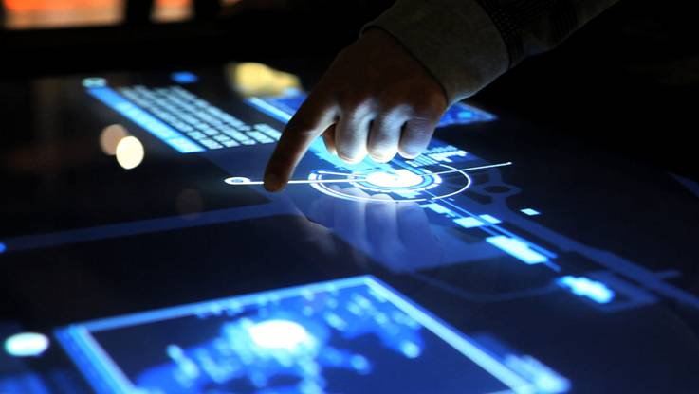

* **Multitouch contact**:
* Surface computing recognizes many points of contact simultaneously, not just from one finger as with a typical touch screen, but up to dozens of items at once

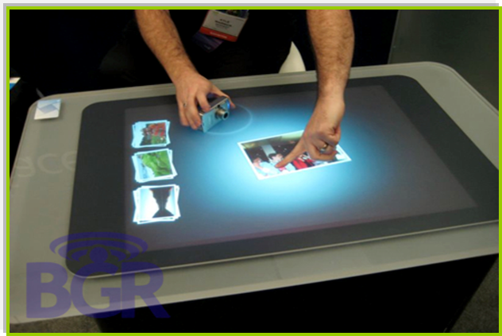

* **Multiuser experience**:
* The horizontal form factor makes it easy for several people to gather around surface computers together, providing a collaborative, face-to-face computing experience.

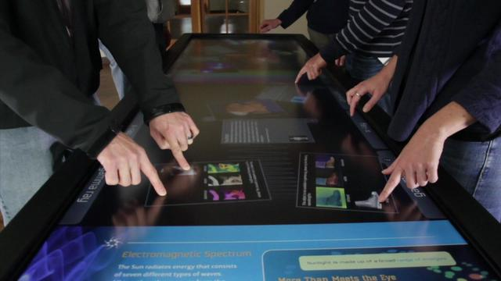

* **Object recognition**:
* Users can place physical objects on the surface to trigger different types of digital responses.

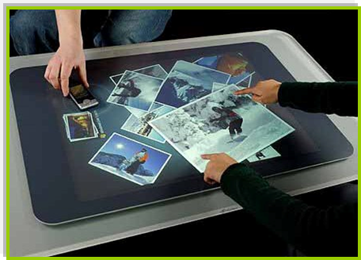

1. **Application:**

* **Paint**:-

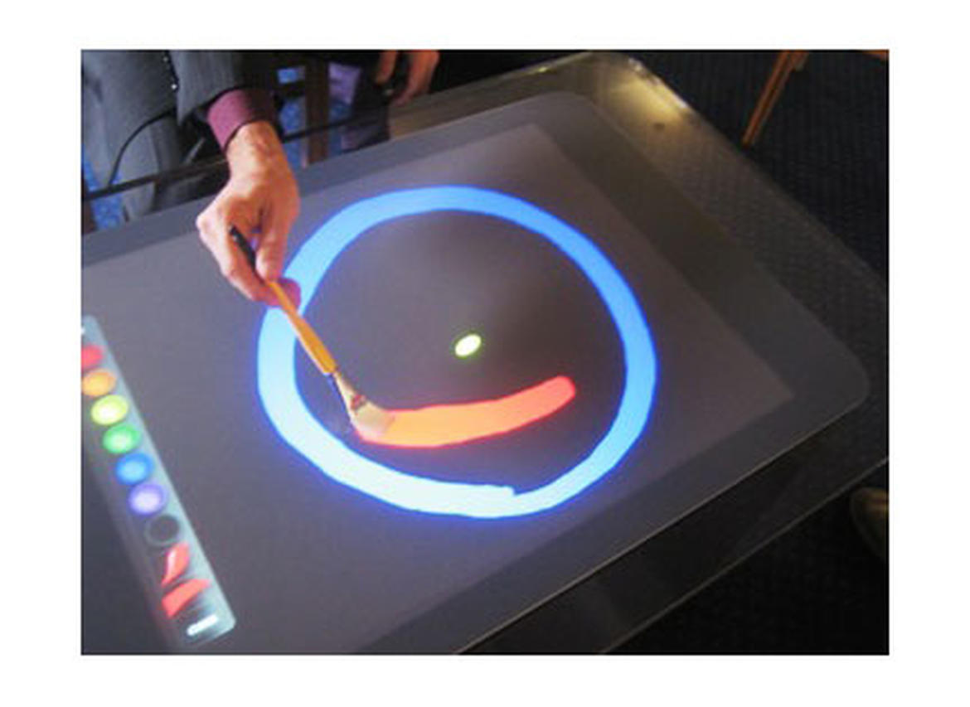

* In Paint Applications ,there are three draw modes that can be toggled by touching an icon on the bottom of the toolbar:-Brush,Paint and Reveal.
* Reveal is a kind of negative brush that showsa background bitmap underneath.
* Brush mode is a bit spotty and tends to skip.
* Paint mode is smooth and fun
* **Music:**-

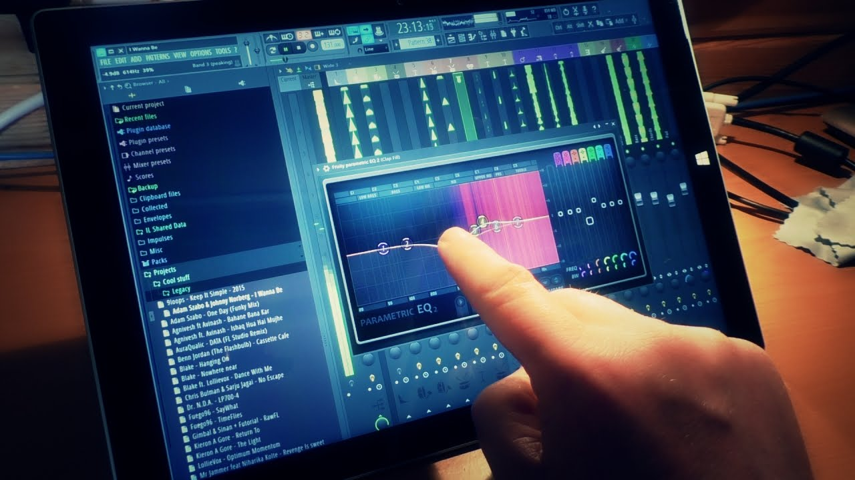

* |This application works like a media player.
* That is, music files are stored and arranged by albums, then select the files and drag into the ―Now playing‖ section.
* Addition, Playing music that is already stored unit’s hardware
* Huge playlist can be easily manipulated.
* **Water:-**

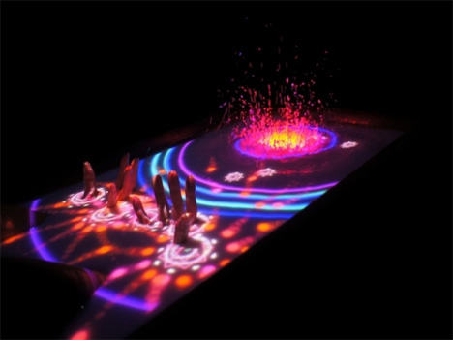

* Water is used as an ―attract mode‖ for Surface desktop.
* The default background picture is an image ofsmooth pebbles that appear to sit a thin layerof rippling water.
* Tapping any ware on the display causes largerripples to spread out from the point of contact.
* **Surface Restaurant:-**

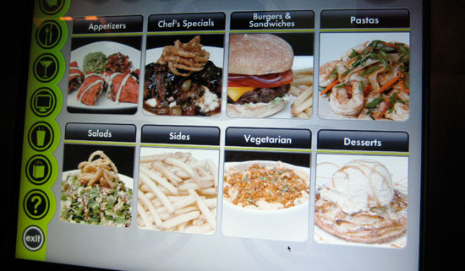

* Orders can be placed on the Surface from a sliding menu , by choosing a category and scrolling left and right through the availableoptions.
* Items can be dragged into a Central ―ordering area‖ and a single tap on the order button sends the list out to the waiter.

1. **Advantage and Disadvantage:**

* **Advantages:**

1. Can handle multiple users at the same time.

2. No wires or USB ports is required.

3. Instant download/upload of photos.

4. Users have more control of technology i.e. ordering food or manipulating photos fast.

5. Time saving by eliminating more processes

* **Disadvantages:**

1. Not portable and very expensive($12,000-$15,000).

2. Need for dim lighting to avoid washing out the screen.

3. Poor Accuracy- Fat fingers are not as accurate as a mouse or stylus.

4. Objects needs to be tagged

1. **Future of Surface Computing :**

* Brand new experience for the PC , laptop & tablet users
* Surface Computing become more mingled with people’s lifestyle and variety of environments
* It will be used in schools, businesses, homes as a part of the countertop.
* Educational environment, where university students could assemble and disassemble quickly and easily.

1. **Conclusion:**

* Microsoft Surface is the future of computers.
* Microsoft Surface breaks down the traditional barriers between people and technology.
* Surface takes existing technology to and presents it in a new way. It is n’t simply a touch screen, but more of a touch-grab-move-slide- resize-and-place-objects-on-top-of-screen, and this open up new possibilities that weren’t before..

1. **References:**
   * + - [https://www.google.co.in/webhp?sourceid=chrome-instant&ion=1&espv=2&ie=UTF-8#q=microsoft+surface+computing+technology&*](https://www.google.co.in/webhp?sourceid=chrome-instant&ion=1&espv=2&ie=UTF-8#q=microsoft+surface+computing+technology&*)
       - <https://en.wikipedia.org/wiki/Surface_computing>
       - <http://www.justin5mins.com/microsoft-presents-multi-touch-surface-computer-features>
       - https://www.slideshare.net/tejalc/surface-computer-ppt
       - http://www.youtube.com/watch?v=CZrr7AZ9nCY•www.microsoftsurface.com